# WEEK- 3 ENTITY FRAMEWORK CORE

**LAB -1 UNDERSTANDING ORM WITH A RETAIL INVENTORY SYSTEM**

**What is ORM?**

Object-Relational Mapping (ORM) is a programming technique that allows developers to interact with a database using object-oriented programming (OOP) concepts instead of writing raw SQL queries. It maps C# classes (models) to database tables, and class properties to table columns.

* **Class - Table**: A C# class (e.g., Product) represents a database table (Products).
* **Properties - Columns**: Each property (e.g., Id, Name) maps to a column.
* **Relationships - Foreign Keys**: Associations (e.g., Product.Category) map to foreign keys.

### **Benefits of ORM**

**Productivity** – Write C# code instead of SQL (e.g., db.Products.Add(product)).  
**Maintainability** – Automatic schema updates via **migrations**.  
**Database Agnostic** – Works with SQL Server, PostgreSQL, MySQL, etc.  
**Security** – Reduces SQL injection risks by using parameterized queries.

Creating a new project

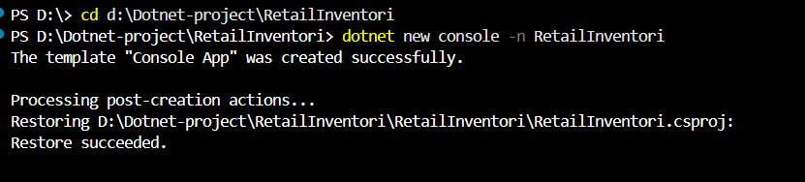

Installing EF Core packages

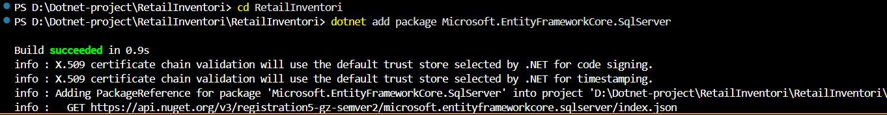

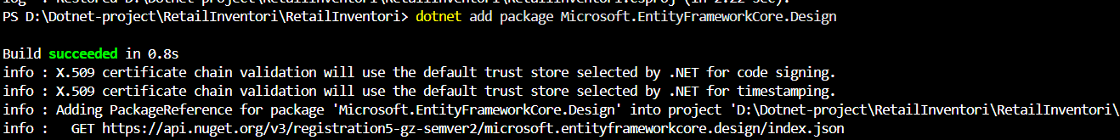

**LAB 2: SETTING UP THE DATABASE CONTEXT FOR A RETAIL STORE**

**1)**

**Product.cs**

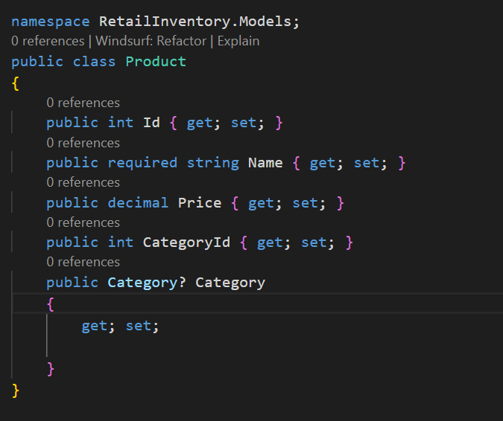

**Category.cs**

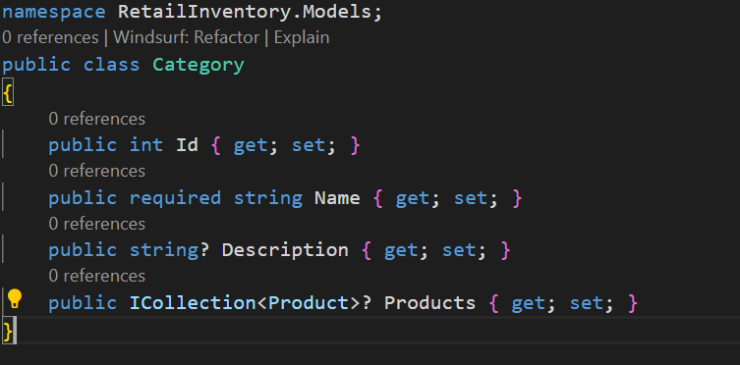

2) AppDbContext

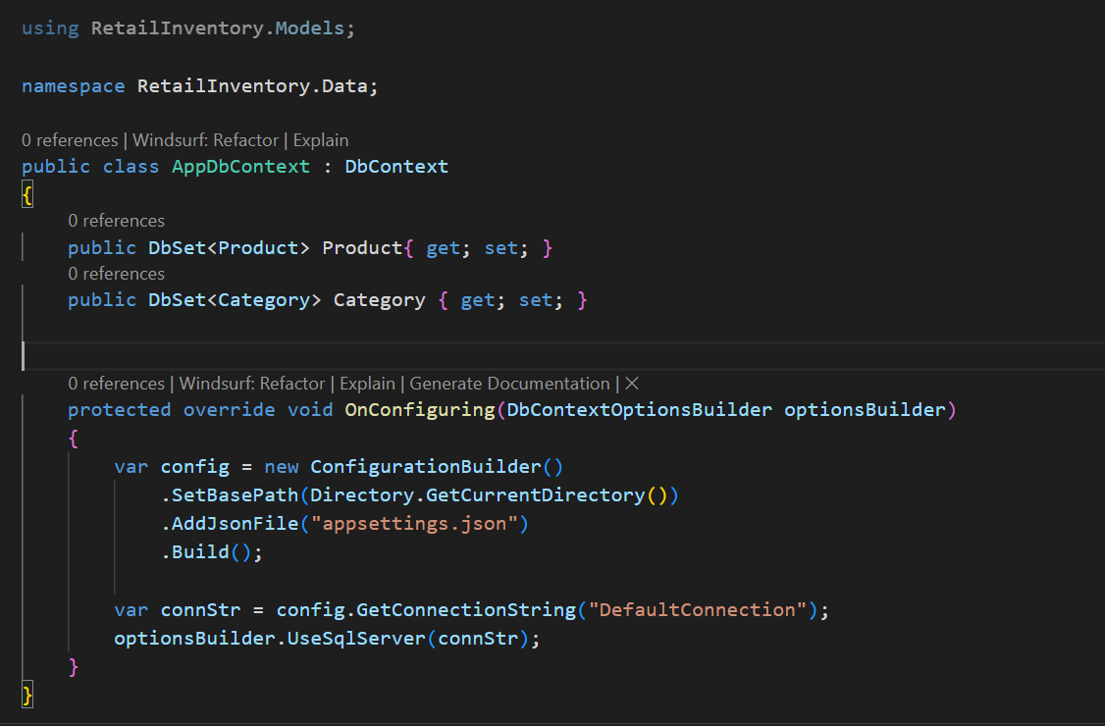

3) appsettings.json

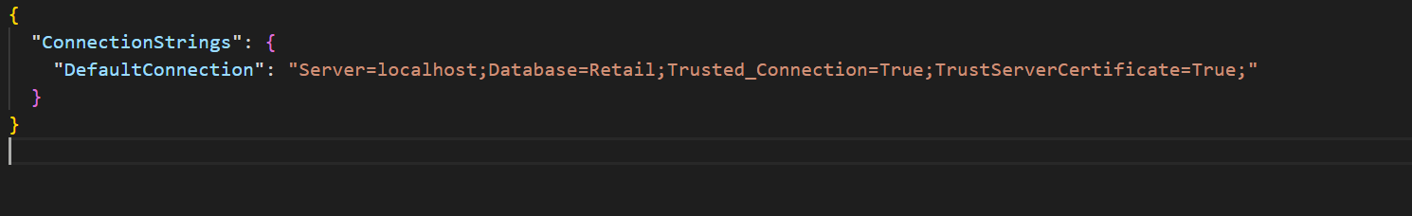

Connection String : **@"Server=localhost;Database=Retail;Trusted_Connection=True;TrustServerCertificate=True;"**

Database in SSMS

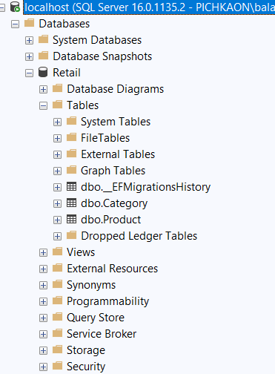

**LAB 3: USING EF CORE CLI TO CREATE AND APPLY MIGRATIONS**

Create Initial Migration

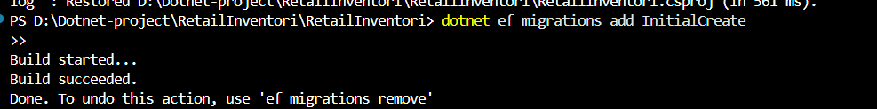

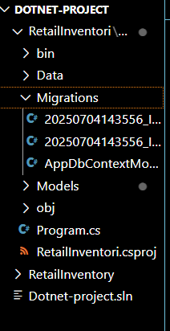

Apply Migration to Create Database:



Updation of database



Table Column in SSMS

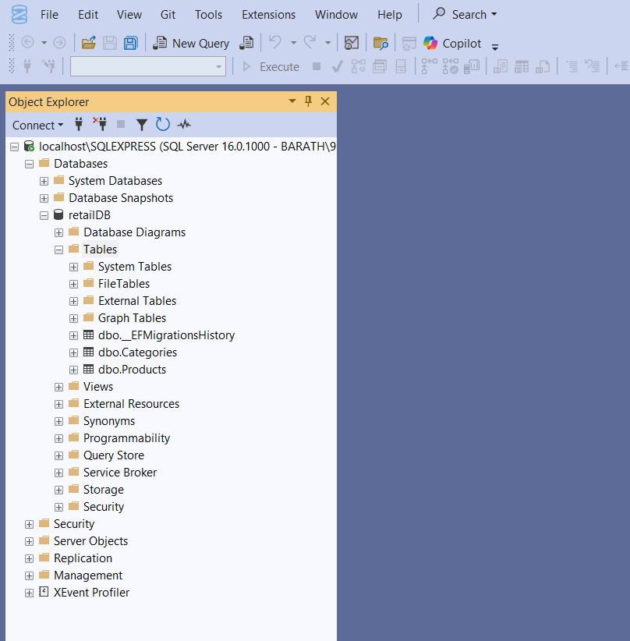

**LAB 4: INSERTING INITIAL DATA INTO THE DATABASE**

**Insertng items in product table in Program.cs**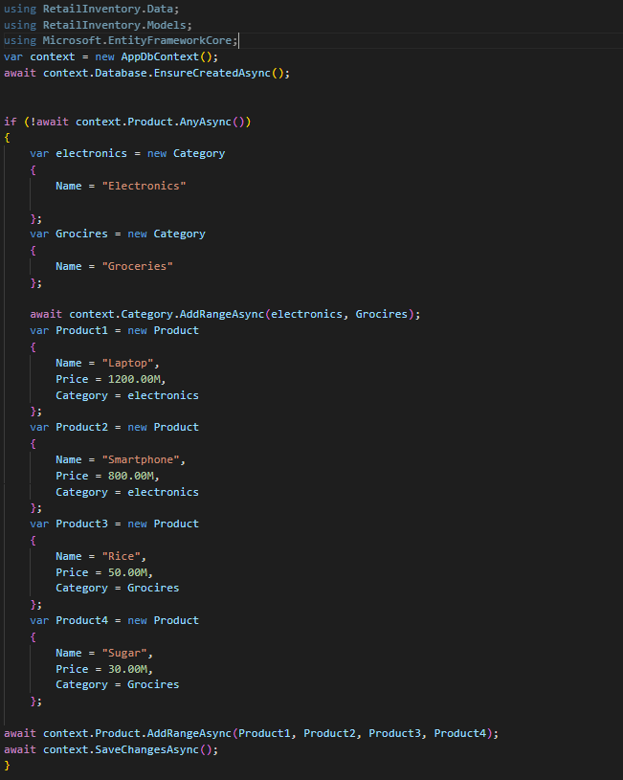

**Running the application**

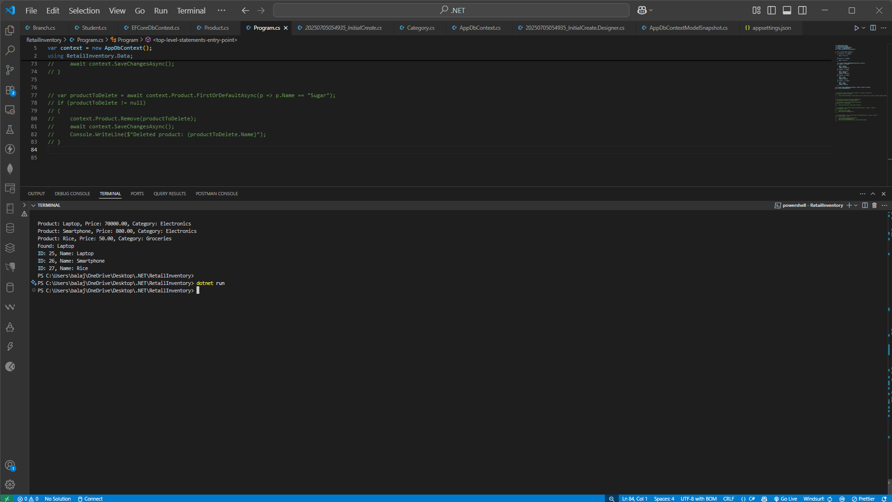

**Using sql queryfor checking table updation**

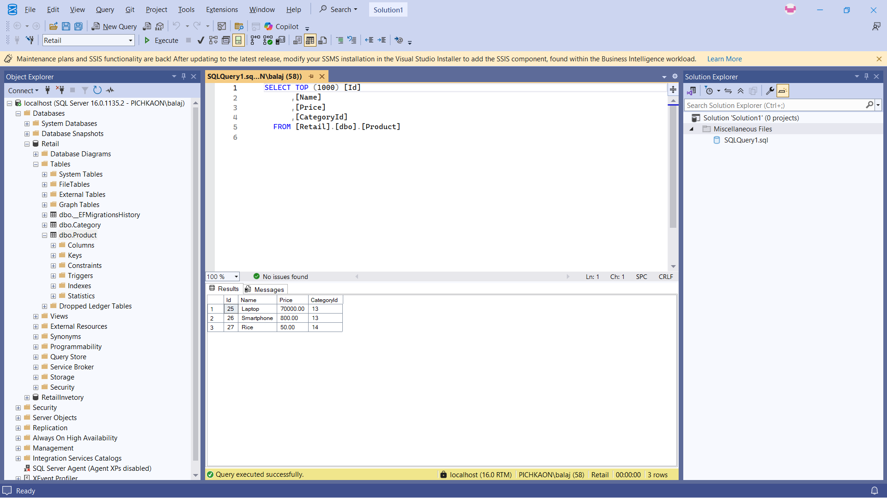

**LAB 5: RETRIEVING DATA FROM THE DATABASE**

1. **Retrieve All Products:**

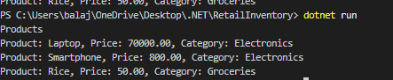

1. **Find by ID**

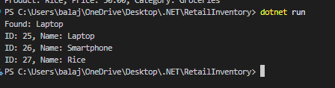

1. **FirstOrDefault with Condition:**

